Long running action
The long running action model (LRA) is designed specifically for those business interactions that occur over a long duration. Within this model, an activity reflects business interactions: all work performed within the scope of an activity is required to be compensatable. Therefore, an activity’s work is either performed successfully or undone. How services perform their work and ensure it can be undone if compensation is required, are implementation choices and not exposed to the LRA model. The LRA model simply defines the triggers for compensation actions and the conditions under which those triggers are executed.
As with most transaction models, LRA is concerned only with ensuring participants obey the protocol necessary to make an activity compensatable; semantics of the business interactions are not part of LRA model. Issues such as isolation of services between potentially conflicting activities and durability of service work are assumed to be implementation decisions. The coordination protocol used to ensure an activity is completed successfully or compensated is not two-phase and is intended to better model business-to-business interactions. Although this may result in non-atomic behaviour for the overall business activity, other activities may be started by the application or service to attempt to compensate in some other manner.
In the LRA model, each activity is bound to the scope of a compensation interaction. LRAs can be nested forming a parent/child relationship. Work performed within the scope of a nested LRA must remain compensatable until an enclosing activity informs the service(s) that it is no longer required. For example, consider the night-out reservation example mentioned earlier.
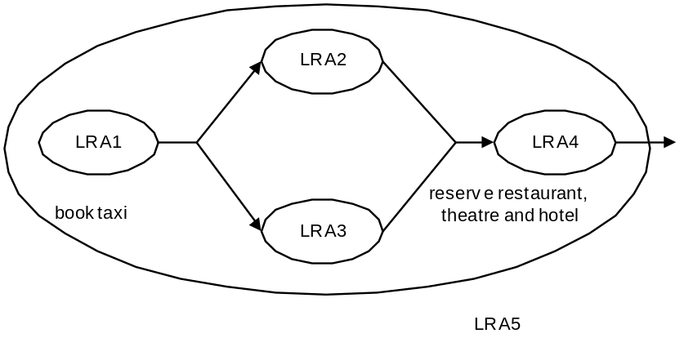
Figure 1: LRA example.
Figure 1 shows how part of the night-out may be mapped into LRAs. All of the individual activities are compensatable. For example, this means that if LRA1 fails or the user decides to not accept the booked taxi, the work will be undone automatically. However, because LRA1 is nested within another LRA, once LRA1 completes successfully any compensation mechanisms for its work are passed to LRA5. In the event that LRA5 completes successfully, no work is required to be compensated, otherwise all work performed within the scope of LRA5 (LRA1 to LRA4) will be compensated.
The coordinator-type URI for the LRA model is http://www.webservicestransactions.org/wstxn/2003/03/tx-lra
In the following sections we shall use the terms LRA and compensation activity interchangeably.

Context
Text on what the context looks like. Pretty simple as we only need the LRA URI type and the coordinator URI and the activity hierarchy, since compensators must be propagated up the chain. The only slight “glitch” I can see is that we want MustUnderstand to be optional. However, this is not a property of the context, but of the client that uses it (see below).

Services and Compensators
In the LRA model, application services fall into one of the following categories:
- Compensatable: the work the service does can be undone (in some implementation specific manner). This may be a transient, such that the work may eventually no longer be compensatable. Such a service can indicate this fact to the business logic directly or via the LRA protocol.
- Not compensatable: the work the service performs cannot be undone.
An ALS for the LRA is associated with the underlying Activity Service. It is up to the user of the augmented context as to whether or not all services invoked within the scope of an LRA must be Compensatable. This choice is made by setting the MustUnderstand attribute appropriately. Obviously by mixing the two service types the user may end up with a business activity that will ultimately not be undone by the LRA model, but which may require outside (application specific) compensation.
A Compensator is the LRA participant that operates on behalf of a service to undo the work it performs within the scope of an LRA. How compensation is carried out will obviously be dependant upon the service.. Because LRAs may execute over a long period of time, compensation may have to occur at any time and be tolerant of failures. Consequently, Compensators may have to maintain information within a durable form.
When a service does work that may have to be later compensated within the scope of an LRA , it enlists a Compensator participant with the LRA coordinator. The Compensator (which is a WS-CF Participant), will be invoked in the following way (illustrated in Figure 2) by the LRA coordinator when the activity terminates:
- SUCCESS: the activity has completed successfully. The Compensators are informed that the activity has terminated and they can perform any necessary cleanups.
- FAIL: the activity has completed unsuccessfully. All Compensators that are registered with the LRA will be invoked to perform compensation (in the reverse order of execution?). The coordinator forgets about all Compensators that indicated they operated correctly. Otherwise, compensation may be attempted again (possibly after a period of time) or alternatively a compensation violation has occurred and must be logged.
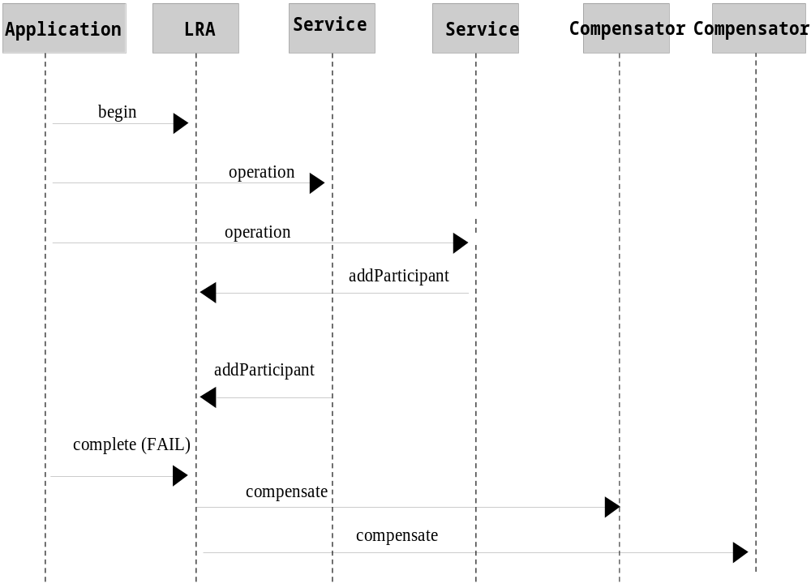
Figure 2: Example LRA interaction diagram.
In order to conduct the protocol, the following message interactions occur between the coordinator and its participants (Compensators), via the solicit-outcome and Outcome messages:
- Compensator: this accepts (via solicit-outcome) the compensate and complete messages, indicating it should either compensate for work or tidy up respectively.
- Coordinator: the Outcome responses the coordinator accepts are compensated, unknownCompensatorFault, cannotCompensateFault, completed and cannotCompleteFault.
The message interactions (via the normal WS-CF Coordinator/Participant solicit-outcome and Outcome exchanges) are shown in Figure 3; not shown are the other Coordinator/Participant message exchanges.
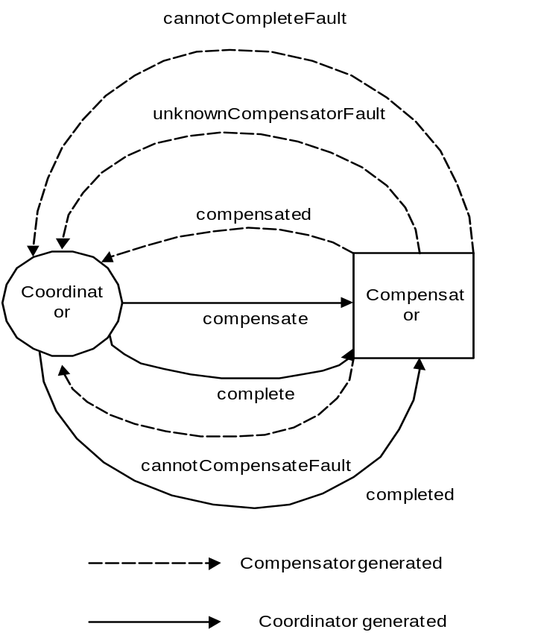
Figure 3: Coordinator-to-Compensator message interactions.
It is expected that the receipt of cannotCompensateFault or cannotCompleteFault will be handled by the application or logged if not.
Note, a Compensator can resign from the LRA at any time prior to the completion of an activity by sending the removeParticipant message to the coordinator. This should obviously be used with care.

State transitions

Qualifiers
When a Compensator is enrolled with an LRA, the entity performing the enrol can supply a number of qualifiers which may be used by the coordinator and business application to influence the overall outcome of the activity. The currently supported qualifiers are:
- TimeLimit: the time limit (in seconds) that the Compensator can guarantee that it can compensate the work performed by the service. After this time period has elapsed, it will no longer be possible to undo the work within the scope of this (or any enclosing) LRA. It may therefore be necessary for the application or service to start other activities to explicitly try to compensate this work. The application or coordinator may use this information to control the lifecycle of an LRA.

Coordinator
LRA uses a presumed nothing protocol: the coordinator must communicate with Compensators in order to inform them of the LRA activity. Every time a Compensator is enrolled with an LRA, the coordinator must make information about it durable so that the Compensator can be contacted when the LRA terminates, even in the event of subsequent failures.

Independent LRAs and application structuring
So far we have not really considered the relationship between LRAs in an application. Obviously LRAs may be used sequentially and concurrently as illustrated in Figure 1, where the termination of an LRA signals the start of some other unit of work within an application. However, LRAs are units of compensatable work and an application may have as many such units of work operating simultaneously as it needs to accomplish its tasks. Furthermore, the outcome of work within LRAs may determine how those LRAs and others may be terminated.
An application can be structured to so that LRAs are used to assemble units of compensatable work and then held in the active state while the application performs other work in the scope of different (concurrent or sequential) LRAs. Only when the right subset of work (LRAs) is arrived at by the application will that subset be confirmed by having the LRAs in which the work occurs complete in a successful state; all other LRAs will be told to cancel (complete in a failure state).
For example, Figure 2 illustrates how a travel agency application may be structured using this technique. LRA1 is used to obtain the taxi to the airport. The user then wishes to get the cheapest flight from three different airlines and so the agency structures each seat reservation (or booking, depending upon how the user feels) as a separate LRA. In this example, the airline represented by LRA2 gives a cost of $150 for the flight; while LRA2 is still active, the application starts LRA3, a new independent-level LRA to ask the next airline for a costing: LRA3 gives a value of $160 and so it is cancelled. Finally the travel agency starts LRA4 to check the other airline, which gives a value of $120 for the seat. Thus, LRA2 is cancelled and LRA4 is confirmed, with the result that the seat is bought. The travel agency then uses the same technique to select the cheapest travel insurance from amongst two options (using LRA5 and LRA6)..
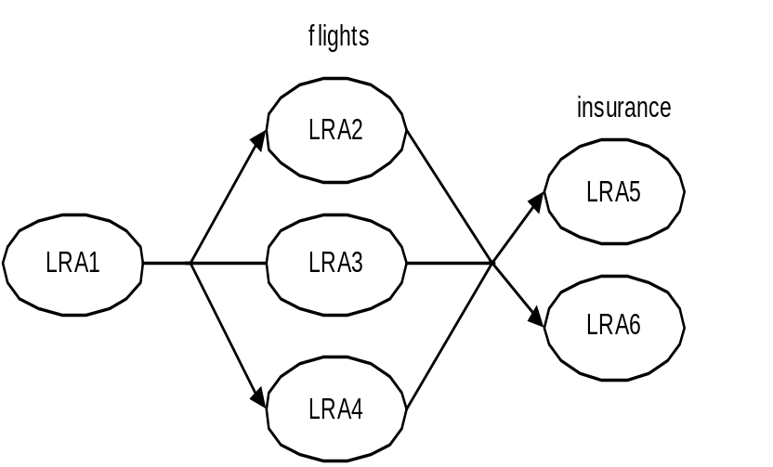
Figure 4: Using LRAs to select units of work.

Recovery
Recovery seems an effect of running the compensators; if they don’t work, log the results somewhere and suspend the activity? Typically the compensators cancel the participants (which might also be LRAs- this is another reason to avoid nesting, since recursion seems more appropriate to the model in which participants can be LRAs – heck I guess it amounts to the same thing ;-)

Status values

